|  |  |
| --- | --- |
| **Server & Cloud Security**  Diploma in CSF/IT  Oct 2022 | Week 4 |
| Tutorial |
| **Cloud Security Basics** | |

1. Briefly discuss the key features / advantages of SaaS model.

|  |
| --- |
| The SaaS is where the customer of the service access application software that is owned and controlled by the cloud company, which has complete responsibility for the management and support of the application.  This model has a lower cost in terms of hardware and software licensing compared to traditional models and it is more scalable be it for small of midl-level businesses. It is also extremely accessible. |

1. Briefly discuss the key features / advantages of PaaS model.

|  |
| --- |
| The PaaS model has the cloud provider assume responsibility for security up to the operating system, and the customer manages the application and operating system configuration.   * **Cost Effective:** No need to purchase hardware or pay expenses during downtime * **Time Savings:** No need to spend time setting up/maintaining the core stack * **Speed to Market:** Speed up the creation of apps * **Future-Proof:** Access to state-of-the-art data center, hardware and operating systems * **Increase Security:** PaaS providers invest heavily in security technology and expertise * **Dynamically Scale:** Rapidly add capacity in peak times and scale down as needed * **Custom Solutions:** Operational tools in place so developers can create custom software * **Flexibility:** Allows employees to log in and work on applications from anywhere |

1. Briefly discuss the key features / advantages of IaaS model.

|  |
| --- |
| The service provider will be responsible for all cloud infrastructure up to the hypervisor level. The customer is reponsible for the VM and higher.   * **Pay for What You Use:**Fees are computed via usage-based metrics * **Reduce Capital Expenditures:** IaaS is typically a monthly operational expense * **Dynamically Scale:** Rapidly add capacity in peak times and scale down as needed * **Increase Security:** IaaS providers invest heavily in security technology and expertise * **Future-Proof:** Access to state-of-the-art data center, hardware and operating systems * **Self-Service Provisioning:** Access via simple internet connection * **Reallocate IT Resources:** Free up IT staff for higher value projects * **Reduce Downtime:** IaaS enables instant recovery from outages * **Boost Speed:** Developers can begin projects once IaaS machines are provisioned * **Enable Innovation:** Add new capabilities and leverage APIs * **Level the Playing Field:** SMBs can compete with much larger firms |

1. Referring to the “Division of Responsibility” diagram by Microsoft, discuss the differences in responsibilities when your workload is hosted on Software as a Service (SaaS), Platform as a Service (PaaS), Infrastructure as a Service (IaaS), or in an on-premises datacenter.

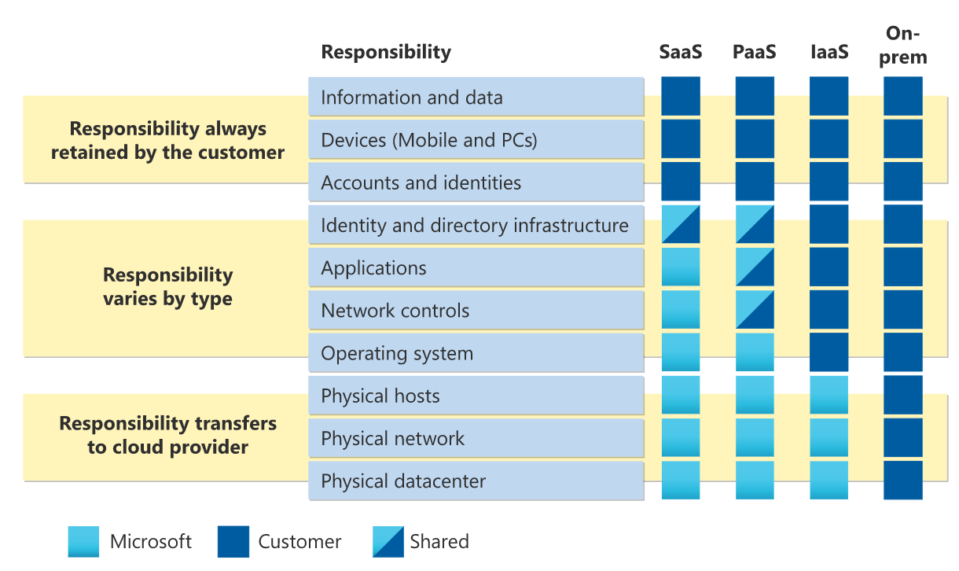

|  |
| --- |
| SaaS. Microsoft is responsible for everything other than customer information and shares responsibility with the customer for identity and directory infrastructure.  PaaS. Like SaaS, but Microsoft shares responsibility with customer for Applications and Network controls.  IaaS. Customers’s responsibility for everything except the hardware.  On premise. Everything is the customer’s responsibility. |

- The End -